Article Layout

УДК 514.76

Ivan I.Ivanov
Immanuel Kant Baltic Federal University
ivanovii@mail.ru
ORCID: http://orcid.org/0000-0002-9935-0232

Title of the article

Abstract The article explores ...

Key words: geometry,…….

Examples of formatting

The scalar curvature of a space-like minimal hypersurface M in de Sitter space S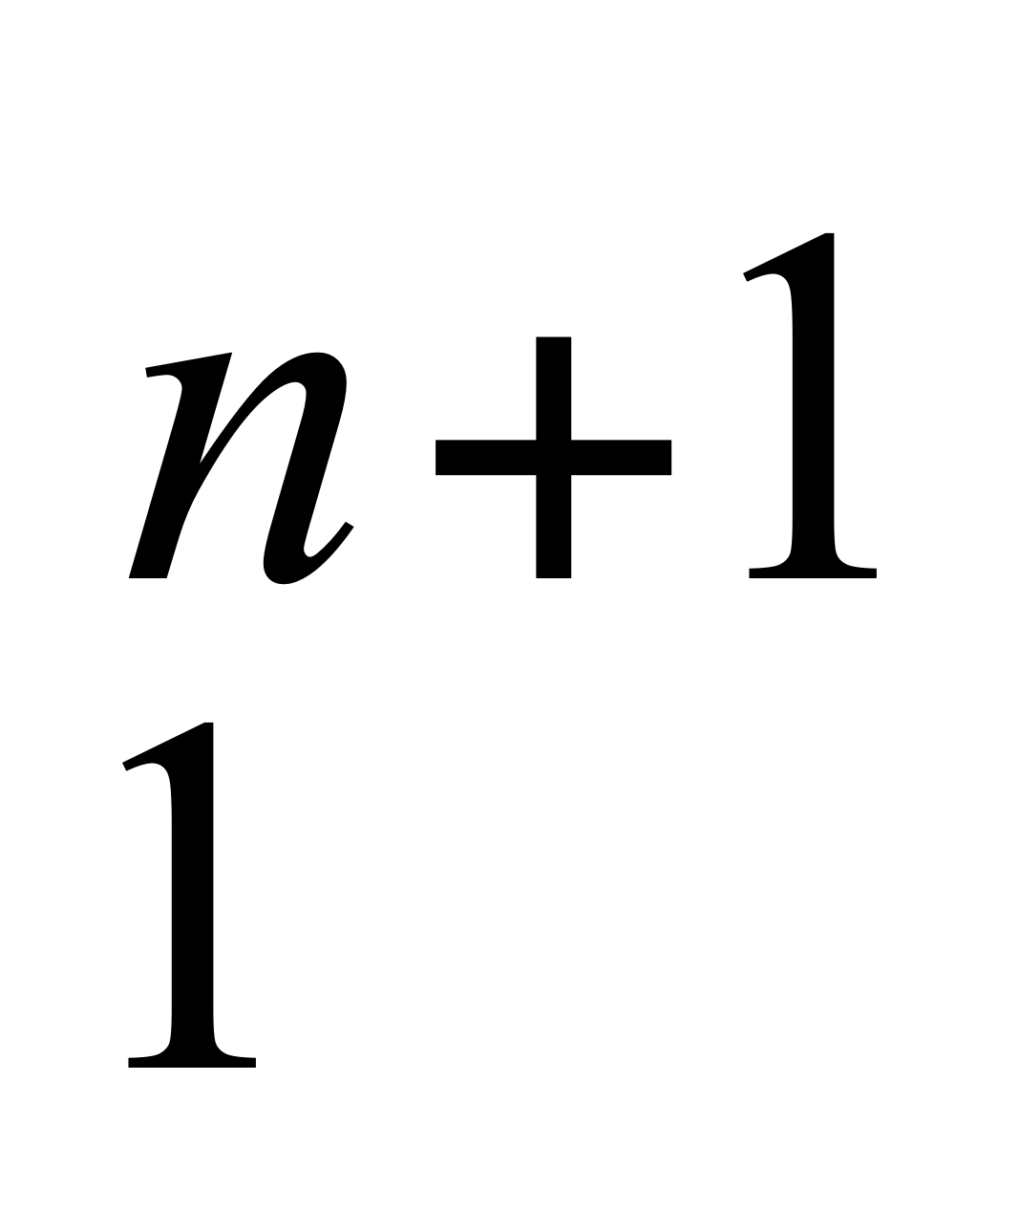 is a positive subharmonic function……

References

1. Akivis, M.A.: Multidimensional differential geometry. Kalinin (1977)
2. Belova, О.O.: Inducing an analog of Neifeld’s connection on the space of centred planes. DGMF, Kaliningrad. 47, 24–28 (2016)
3. Shevchenko, Yu.I.: Degeneration of Stolyarov’s plane affine connection. J. Math. Sci., 177:5, 753–757 (2011)
4. Shevchenko Yu.I. On generalizations of the projective Cartan connection on a smooth manifold. IKBFU'sVestnik. Ser. Physics, Mathematics, and technology. Kaliningrad. 10, 60–68 (2014)
5. Zhong, C.: On unitary invariant strongly pseudoconvex complex Finsler metrics. Differ. Geom. Appl. 40, 159–186 (2015)
6. Xia, H., Zhong, C.: A classification of unitary invariant weakly complex Berwald metrics of constant holomorphic curvature. Differ. Geom. Appl. 43, 1–20 (2015)
7. Walsh, J.B.: An introduction to stochastic partial differential equations. In: Ecole d’été de Probabilités de St. Flour XIV, Lecture Notes in Mathematics, 1180, 266–439. Springer, Berlin (1986)
8. Berezanski, Y.M., Kondratiev, Y.G.: Spectral Methods in Infinite-Dimensional Analysis. Springer, Berlin (1995)
9. Filipuk, G., Van Assche, W., Zhang, L.: Ladder operators and differential equations for multiple orthogonal polynomials. http://arxiv.org/abs/1204.5058. Accessed 1 May 2012

About the author

Dr Alexey A. Ivanov, Senior Researcher, Immanuel Kant Baltic Federal University, Russia.
Email: AIvanov@kantiana.ru
ORCID: https://orcid.org/0000000245019052

